GOALPARA COLLEGE, GOALPARA
B A 6th SEMESTER RESULT-2023
Dept of Education
Total Appeared- 32
Total Pass- 32
Pass percentage- 100%
Roll UA-201-099-0
Nos: 002, 0011, 0012, 0014, 0017, 0038, 0039,0044, 0046, 0067,0070, 0076, 0083, 0088, 0089, 0107, 0111, 0129, -0130, 0134, 0150, 0158, 0167, 0168, 0174, 0183, 0206, 0208, 0236, 0238, 0250, 0257.
Total = 32
C Sarangi
Head, Dept of Education
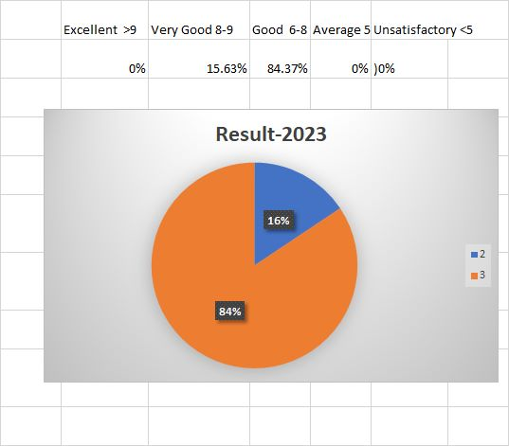
Final Result -2023
Sl no. | Roll No | Name | Mark(CGPA) | %
1 | UA-201-099-0002 | ABDUL HAMID | 8.19 | 81.9
2 | UA-201-099-0011 | AFSANA YASMIN | 6.74 | 67.4
3 | UA-201-099-0012 | AFTAB AHMED | 7.07 | 70.7
4 | UA-201-099-0014 | AJMINA KHATUN | 7.73 | 77.3
5 | UA-201-099-0017 | ALLA UDDIN | 7.88 | 78.8
6 | UA-201-099-0038 | AYESHA SHIDDIKA | 7.12 | 71.2
7 | UA-201-099-0039 | AYUBUR RAHMAN | 7.00 | 70.0
8 | UA-201-099-0044 | BANDITA NATH | 6.74 | 67.4
9 | UA-201-099-0046 | BARASA RANI RABHA | 7.38 | 73.8
10 | UA-201-099-0067 | DIPANNEETA ROY | 7.86 | 78.6
11 | UA-201-099-0070 | DIYA SARAKAR | 7.38 | 73.8
12 | UA-201-099-0076 | FORIDUL TALUKDAR | 7.43 | 74.3
13 | UA-201-099-0083 | HANGSHIKA BISWAS | 6.50 | 65.0
14 | UA-201-099-0088 | HIMA RANI RABHA | 7.09 | 70.9
15 | UA-201-099-0089 | HIYA MONI JOTDAR | 8.41 | 84.1
16 | UA-201-099-0107 | JEETU RANJAN NATH | 7.73 | 77.3
17 | UA-201-099-0111 | JURI NATH | 8.20 | 82.0
18 | UA-201-099-0129 | MADHUSHMITA PAUL | 7.01 | 70.1
19 | UA-201-099-0130 | MADHUSHMITA RABHA | 8.47 | 84.7
20 | UA-201-099-0134 | MANASHI RABHA | 7.97 | 79.7
21 | UA-201-099-0150 | MIZANUR RAHMAN | 6.61 | 66.1
22 | UA-201-099-0158 | MORJINA KHATUN | 7.39 | 73.9
23 | UA-201-099-0167 | NAHIN KAUCHAR | 7.76 | 77.6
24 | UA-201-099-0168 | NARJINA YASHMIN | 7.27 | 72.7
25 | UA-201-099-0174 | NIKITA GOSH | 7.74 | 77.4
26 | UA-201-099-0183 | PAMPI SARKAR | 7.96 | 79.6
27 | UA-201-099-0206 | RUHUL AMIN | 7.72 | 77.2
28 | UA-201-099-0208 | RUKSANA YAHMIN | 8.68 | 86.8
29 | UA-201-099-0236 | SEMPOLISH MARAK | 6.81 | 68.1
30 | UA-201-099-0238 | SAHABUDDIN MONDAL | 6.50 | 65.0
31 | UA-201-099-0250 | SUSHMITA DAS | 7.77 | 77.7
32 | UA-201-099-0257 | TUSLIMA BEGUM | 7.12 | 71.2

RESULT ANALYSIS-2023
Name | HC-6016 | HC-6026 | HE-6016 | HE-6036
ABDUL HAMID | 8 | 10 | 8 | 8
AFSANA YASMIN | 6 | 8 | 7 | 5
AFTAB AHMED | 6 | 10 | 6 | 4
AJMINA KHATUN | 7 | 10 | 8 | 7
ALLA UDDIN | 6 | 10 | 8 | 6
AYESHA SHIDDIKA | 6 | 9 | 8 | 6
AYUBUR RAHMAN | 6 | 9 | 8 | 6
BANDITA NATH | 6 | 9 | 7 | 5
BARASA RANI RABHA | 7 | 9 | 8 | 6
DIPANNEETA ROY | 7 | 9 | 9 | 7
DIYA SARAKAR | 7 | 9 | 9 | 7
FORIDUL TALUKDAR | 7 | 8 | 5 | 7
HANGSHIKA BISWAS | 5 | 9 | 6 | 4
HIMA RANI RABHA | 5 | 9 | 7 | 5
HIYA MONI JOTDAR | 7 | 10 | 9 | 7
JEETU RANJAN NATH | 7 | 8 | 8 | 6
JURI NATH | 8 | 10 | 9 | 8
MADHUSHMITA PAUL | 6 | 9 | 8 | 5
MADHUSHMITA RABHA | 8 | 10 | 8 | 7
MANASHI RABHA | 6 | 10 | 9 | 6
MIZANUR RAHMAN | 6 | 9 | 4 | 5
MORJINA KHATUN | 8 | 9 | 6 | 6
NAHIN KAUCHAR | 7 | 10 | 6 | 6
NARJINA YASHMIN | 6 | 9 | 6 | 6
NIKITA GOSH | 6 | 10 | 6 | 5
PAMPI SARKAR | 8 | 10 | 7 | 7
RUHUL AMIN | 8 | 10 | 6 | 5
RUKSANA YAHMIN | 8 | 10 | 7 | 7
SEMPOLISH MARAK | 7 | 9 | 4 | 5
SAHABUDDIN MONDAL | 6 | 9 | 4 | 4
SUSHMITA DAS | 7 | 9 | 7 | 7
TUSLIMA BEGUM | 6 | 9 | 5 | 5

