World Water Day 2022
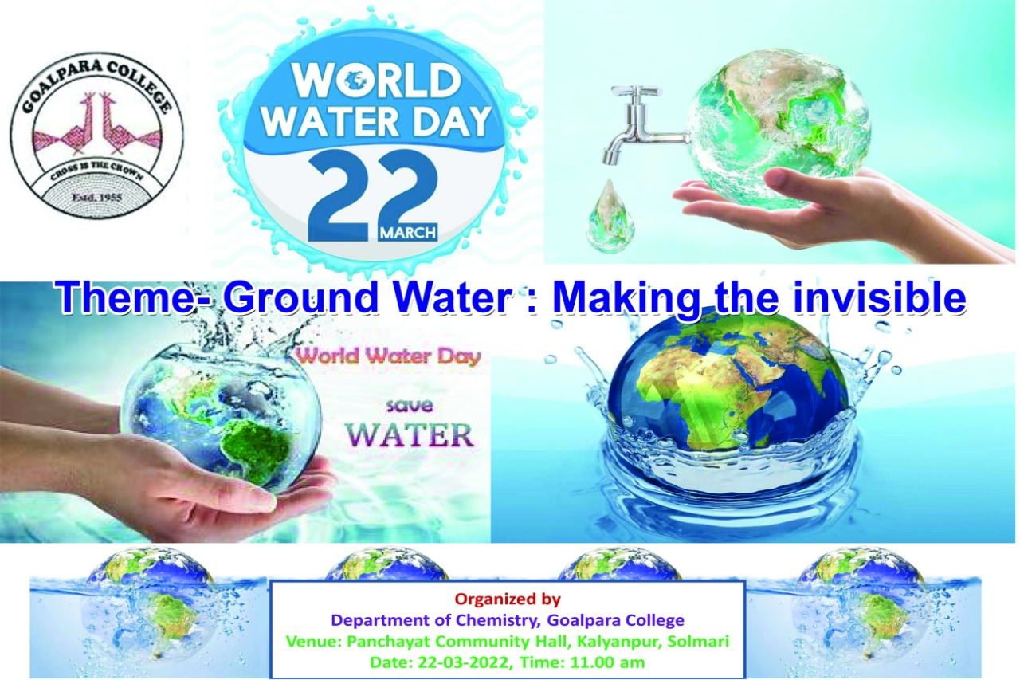
Theme of World Water Day-2022: “Groundwater: Making the invisible visible. This year World Water Day 2022 was observed at Kalyanpur High School, Solmari, Goalpara. Head of the Department of Chemistry Dr. Basanti Ray Dutta gave talk on how to conserve water. Mr. Mukut Bharali, Chemist from PHED Goalpara Division demonstrated on how to check Water quality. Six semester students from our department were present along with other students. Dr. Sandhya Rani Gogoi, Dr. Mithu Saha and Dr. Arshad H. Khan were also present. The community people also participated.

