ALUMNI MEET 2022
CHEMISTRY DEPARTMENT
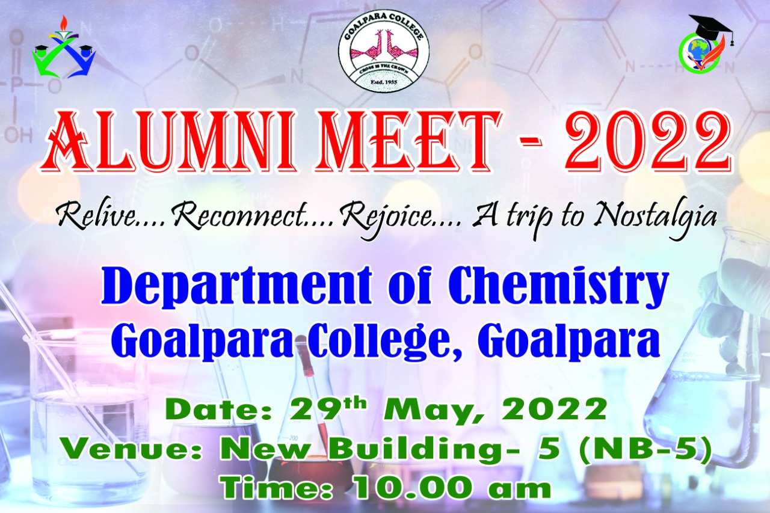

Alumni meet was organized by Chemistry Department of Goalpara College on 29TH May 2022. The alumni meet wasorganised this year in order to reconnect with the Alumni and celebrate their success and various achievements.The programme was inaugurated by our principal Dr. Subhash Barman. Head of the Department of Chemistry Dr. Basanti Ray Dutta, welcomed all the dignitaries and all the alumni for responding to the invitation from the department and being present for the alumni meet in spite of their busy schedule.Pankaj Kumar Das (officer, NE Frontier Railway) and Dhiru Barman (Librarian, B.B. engineering college) were the moderators in the programme. Founders and Retired Head of the Department of Chemistry Thaneswar Sarma and Amulya Sarma delivered lecture on how to uplift the department from various aspects and also the ways to contribute our help to thesociety.Also retired Head of the Depatment of Chemistry R.C. Barman and A. Barik (demonstrator) graced the programme.
Our alumni Prof. Manabendra Sarma, from IIT Guwahati interacted with the students. He guided and motivated them to choose proper career after graduation and ways to excel in competitive examinationsDr. Anup Kr. Ray (alumni), Principal, Goalpara Law College delivered lecture on how to connect law with chemistry.
Vote of thanks proposed by Dr. Anup Kr. Ray
He thanked the Alumni for taking the time to come for the Alumni Meet who have made it a very special and memorable one. He thanked the various organizers of the event (teaching, non-teaching staff and the enthusiastic student volunteers) whose hard work and dedication made the event possible.

.

