Population interactions…
Interspecific interactions arise from the interaction of populations of two different species. Theoretically, populations of two species may interact in basic ways that correspond to combinations of neutral, positive, and negative (0, +, and -) as follows: 0 0, - -, + +, + 0, - 0, and + -. Three of these combinations (+ +, - -, and + -) are commonly subdivided, resulting in nine important interactions and relationships. These are as follows:-
1. Neutralism, in which neither population is affected by association with the other;
2. Mutual inhibition Competition type, in which both populations actively inhibit each other;
3. Competition, resource use type, in which each population adversely affects the other indirectly in the struggle for resources in short supply;
4. Amensalism, in which one population is inhibited and the other not affected;
5. Parasitism; and
6. Predation, in which one population adversely affects the other by direct attack but is nevertheless dependent on the other;
7. Commensalism, in which one population is benefited, but the other is not affected;
8. Proto-cooperation, in which both populations benefit by the association but their relations are not obligatory; and
9. Mutualism, in which the growth and survival of both populations is benefited, and neither can survive under natural conditions without the other.
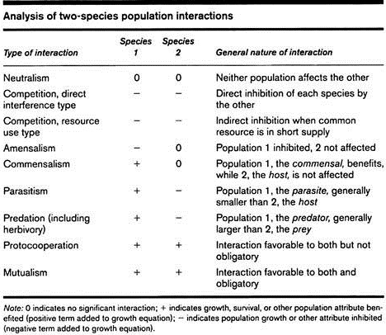
Types 2-4 are “negative interactions”, Types 7-9 are “positive interactions”, Type 5 & 6 as “both positive & negative interactions”
The nine interactions listed above are likely to occur in any large-scale biotic community, such as a large tract of forest, wetland, or grassland. For a given species pair, the type of interaction may change under different conditions or during successive stages in their life histories. Thus, two species might exhibit parasitism at one time, exhibit commensalism at another, and be completely neutral at still another time.
- Neutralism: When two different species population are not affected by the association with one another, it is called neutralism. For example, grass carp and Catla residing on the surface of a pond do not affect on another as their food habits are quite different. Grass carp feeds on macro vegetation while Catla feeds on zooplankton.

- Competition: It is an interaction among two organisms utilizing a limited resource (example: food, space etc.) resulting in reduced fitness in the competing individuals.

A. Direct or interference competition:
It occurs when two species come into direct contact with each other. Direct competition occurs more frequently in the animal world, from simple filter-feeding protozoans and cladocerans to vertebrates.
B. Indirect or exploitation competition:
It occurs when one species exploits a resource (such as food, space etc.) in common with another species but without direct contract with that species. This indirect competition in exploitation of resources can provide a competitive advantage for one species against another.
- Amensalism: It is an interaction between organisms of different species in which one organism is inhibited while the other organism remains unaffected. The organism which inhibits the growth of another organism is called amensal. It is carried out with the help of chemicals called allochemics. Eg. Osimum sanctum (Tulsi) inhibits the growth of other plants around it.

- Commensalism: Commensalism is an interaction between two species in which one species gets benefited while the other remains unaffected. Eg. An orchid growing on the branches of a mango tree and barnacles attached to the body of whales are examples of commensalisms.

- Parasitism: It is an interaction between two species in which one species (usually smaller) gets positively affected, while the other species (usually larger) is negatively affected. Eg. Liverfluke is a parasite that lives inside the liver of the host body and derives nutrition from it. Hence, the parasite is benefited while the host is negatively affected as the parasite reduces the host fitness, making its body weak.

- Predation: It is an interaction between two species in which one organism (predator) kills and eats another organism (its prey). The predator has negative effect on prey population while prey has no effect on predator population density. Eg. Tiger preying on deer.

- Proto-cooperation: It is a mutually beneficial association between two species where both the species are benefited but these relationships are not obligatory for their survival. Eg. association between hermit crab and sea anemone

- Mutualism: It is an interaction between two species in which both species involved are benefited. Eg. Lichens show a mutual symbiotic relationship between fungi and blue green algae, where both are equally benefited from each other.

--€€€€€€€€€€€€€€€--

