DEPARTMENT OF HISTORY
GOALPARA COLLEGE, GOALPARA
PIN-783101, ASSAM

Notice
13/06/2023

This is for general information of all students of Semester-IV having Skill Paper in History (Oral Culture & Oral History) Paper Code-HIS-SE-4014 of Goalpara College that the date for field Visit is scheduled on 14th June, 2023 for Group-A and 19th June, 2023 for Group-B.
All students of concerned group are hereby asked to get prepared for the said work and for more information contact the head of the department and faculty members.

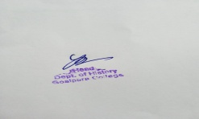
(Yasavanta Ray)
HoD

