NATIONAL ENERGY CONSERVATION DAY-2022
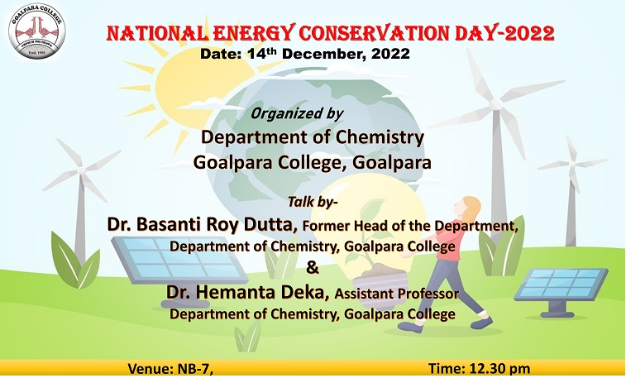
The National Energy Conservation Day was observed on 14/12/2022. Head of the Department of Chemistry Dr. Arshad H. Khan gave introductory speech on how it initially started and the importance to saving energy. Principal of Goalpara College Dr. Subhash Barman and IQAC Co-ordinator Dr. Dulal Baruah gave important speech on how to conserve energy. A presentation was given by Dr. Hemanta Deka, Assistant Professor of Chemistry Department on the topic “Energy efficiency, a futuristic perspective”. Former Head of the Department of Chemistry Dr. Basanti Ray Dutta gave talk on how to conserve energy. A quiz competition was organised on that day. Dr. Mithu Saha asked the students many questions related to energy conservation, thermal plants, etc. Lastly, vote of thanks given by Dr. Valentina Basumatary.
