WORLD BIOFUEL DAY-2022
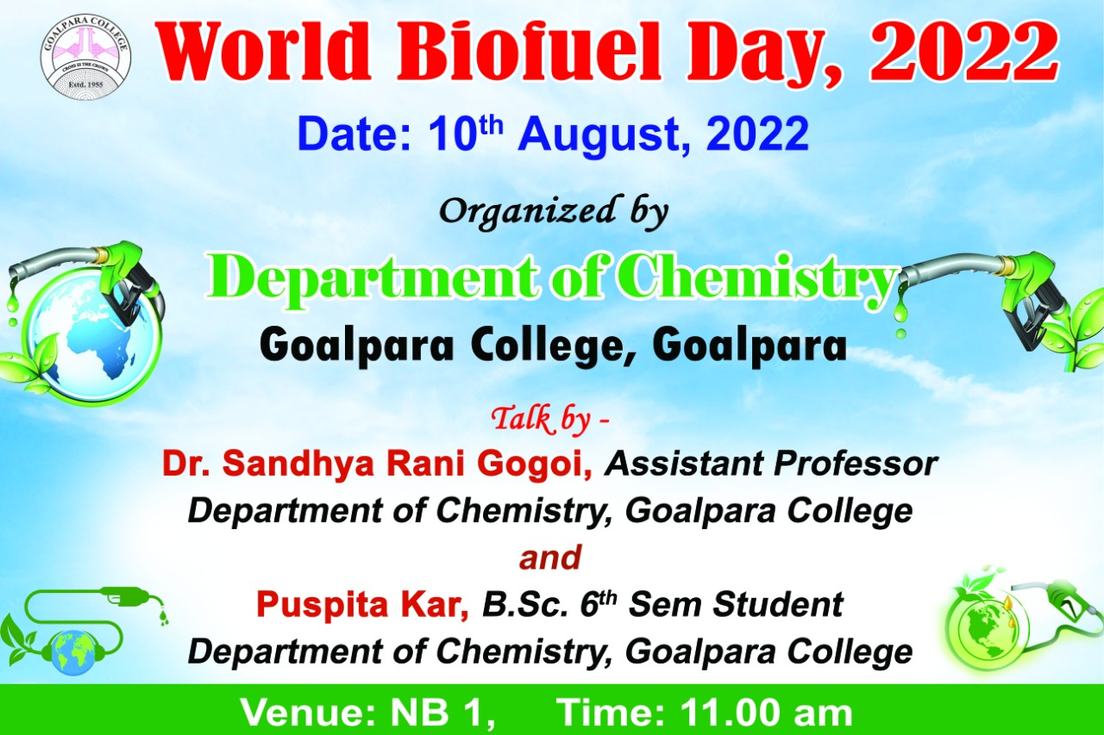
It was observed on 10/08/2022 presentation given by Dr. Sandhya Rani Gogoi and final year chemistry student Puspita Kar. Head of the Department of Chemistry Dr. Arshad Hussain Khan inaugurated the programme. Dr. Sandhya Rani Gogoi gave presentation on the importance of Biofuel and final year chemistry student Puspita Kar on applications of Biofuel. Altogether 33 students from all the semester participated.
