QUIZ COMPETITION
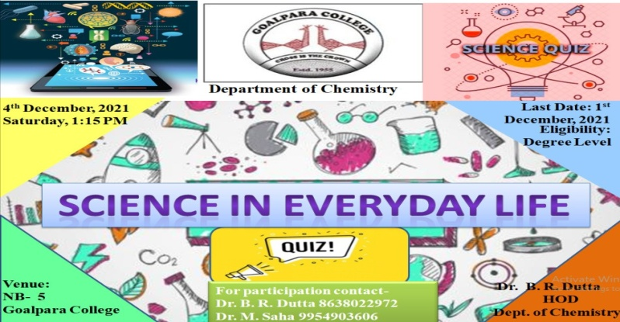
Quiz Competition was organized by the Department of Chemistry on 4th March 2021. Head of the Department of Chemistry Dr. Basanti Ray Dutta inaugurated the programme. Altogether 30 students participated from the different department of the college. Quiz master Dr. Basanti Ray Dutta and Dr. Mithu Saha carried out the programme successfully. All the 30 students gave a screening test out of which 12 students finally took the seat for the quizzes.

